

Adam Wilkie

Before beginning this project, first I had to find a topic. I thought of numerous ideas, a Guitar Database, a Bands Database, a Food Database, but I ended up settling on a Clash Royale Database.

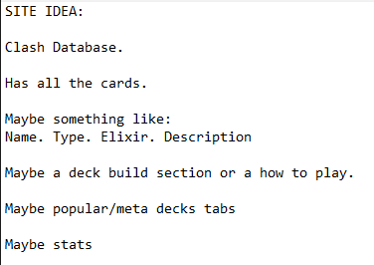

This here was my first original plan, a database that holds information about Clash Royale cards, including details such as name, elixir cost, type (troop, building, or spell) and description. I chose Clash Royale because it’s one of my favourite games, and it provides a fun yet structured dataset with meaningful statistics that can easily be organised, searched, and displayed using SQL and a web interface.

From the start, I wanted to make my project more than just a static webpage — I wanted to create an interactive web application that allows users to search, sort, and filter cards based on criteria such as elixir cost or rarity. The database will be connected to the front-end using Flask (Python) for the back-end logic, HTML and CSS for the layout and styling, and JavaScript to add interactivity such as real-time search filtering and sorting.

The overall goal of my project is to make a Progressive Web App (PWA) that can run both on desktop and mobile devices, offering a simple and user-friendly interface for browsing all the cards in Clash Royale. I want users to be able to not only view card information but also query the database efficiently, for example finding all Legendary cards under 5 elixir, or viewing all cards that belong to the Epic rarity.

This project will also give me a chance to apply core software-engineering principles — such as modular design, data validation, usability, and testing — while learning how to combine front-end and back-end development into one cohesive system. I will document my progress as I go, including the creation of my directory structure, Gantt chart, and storyboard.

This here was my first original plan. A database that holds